Homework #2
Due: 8 February 2024

1. SAVING/INVESTMENT & TRADE BALANCE IN THAILAND

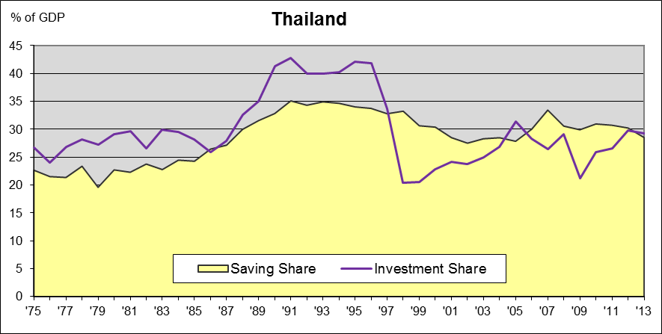
Consider the saving and investment rates for Thailand shown in the figure.
a) What is implied about foreign capital flows during 1990-1997? … during 1998-2003?
b) What is implied about the trade balance during the two periods?

2. SAVING AND ECONOMIC DEVELOPMENT
During periods of growth take-off in developing countries, the national saving rate tends to rise (note case of Thailand above and Taiwan in class). Ceteris paribus, this will tend to choke off growth as household consumption demand fails to support sustained output increases.
- What other sources of aggregate demand can help to sustain growth?
(Hint: Aggregate demand is given by the expenditures equation for GDP.)
- How can government policy foster these other sources of aggregate demand?

3. BALANCE OF PAYMENTS ACCOUNTING
a) Suppose an exporter understates foreign exchange receipts in his reporting to authorities. Why might he do this? What do you suppose happened to the receipts? What two entries would be needed to correctly capture this activity on the balance of payments?
b) Suppose the Indonesian central bank must defend the value of the rupiah against a sell-off. How does it intervene in the foreign exchange market? How is this reflected in the balance of payments?
c) For the Chinese renminbi to become an international reserve currency, as the Chinese government desires, what are the implications for China’s balance of payments?

