Homework #6
Due: 15 April 2024

- Subduing inflation.
To rein in inflation, what action can the central bank take using the following policy tools?
- government bonds
- foreign assets
- reverse repurchase rate
- reserve requirement ratio
- interest rate on reserves

- Reducing a current account deficit.
To reduce a current account deficit, what action can the central bank take using the following policy tools? (Hint: Consider the effect of a change in PQ on X and M.)
- government bonds
- foreign assets
- reverse repurchase rate
- reserve requirement ratio
- interest rate on reserves

- Singapore monetary policy.
How will the Monetary Authority of Singapore be inclined to adjust its exchange rate target in response to the following changes in circumstances?
  - rising domestic inflation
  - declining global prices for its exports
  - rising US interest rates

- BSP response to external shock.
The chart below shows Philippine exchange rate movement and central bank reserve acquisition within the Emerging East Asia context for the period 2008-2022.
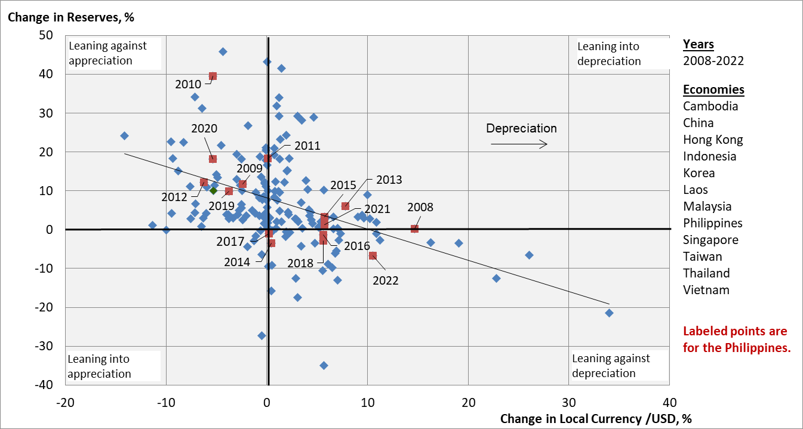
- In 2008, the peso depreciated by nearly 15 percent vs the US dollar. What are the consequences of such depreciation for: (i) exporters; (ii) importers; (iii) OFWs sending remittances; (iv) borrowers in foreign currency?
- In 2008, what action could the BSP have taken in the forex market to restrain depreciation of the peso, and why might it have chosen not to do so?
- In 2009 and 2010, the BSP intervened in the forex market to increase reserves by a cumulative 58 percent. What are the consequences of this for: (i) the value of the peso; (ii) the BSP balance sheet; (iii) nominal GDP growth?
- Over the period 2008-2022, what can you say about BSP strategy for exchange rate and reserve managment?

